College | RV COLLEGE OF ENGINEERING®
Department | COMPUTER SCIENCE AND ENGINEERING
PROGRAM | M. Tech | MINOR PROJECT | Course Code | 22MCE33P
Student Name1 |  |  | USN1
Student Name2 |  |  | USN2
Project Title | Title
Undertaken at | RV COLLEGE OF ENGINEERING
Internal  Guide | Name  Dr. |  | Designation  Associate Professor
INTRODUCTION: Prolonged COVID-19 has emerged as a significant concern globally, with a subset of individuals experiencing persistent symptoms long after the acute phase of the infection. Understanding the genomic basis of prolonged COVID-19 can provide crucial insights into its pathophysiology and aid in the development of targeted therapeutic strategies.

OBJECTIVES: The following are the objectives,
- To gather the population genetic sequence data for analysis with reference genome of SARS-COV-2
- To identify and characterize genetic variants associated with population infected from the SARS-COV-2 virus thus suffering from the prolonged Covid-19 symptoms
- Provide actionable insights into potential health impacts and management strategies
- Extend the scope of the developed application tool to analyze other virus caused diseases
- Integrate advanced computational techniques like SNP analysis, population genetics, machine learning, web interface for comprehensive analysis and to map the analyzed genetic variants to biological pathways and organ systems, predicting their impact.

SOFTWARE REQUIREMENTS:
- BASH/Shell Interface to run the scripts
- Tools: BWA tool, SAMtools, BCFtools, BLAST

HARDWARE REQUIREMENTS:
- 8 GB of RAM, 512GB of Hard Disk/SSD
- Pentium IV Processor or better

METHODOLOGY: Retrieve the genetic sequences of population with prolonged covid-19 from the National Center for Biotechnology Information (NCBI) database available in fasta format. Process the huge dataset and align the DNA sequences using binary alignment mapping. Identify the genetic variants through the freebayes algorithm. From the generated variant output, characterize the single nucleotide polymorphisms (SNPs) prevalent. Map the identified SNPs to relevant pathways to elucidate their potential functional significance in the context of the disease.
The following is the proposed workflow of the project,
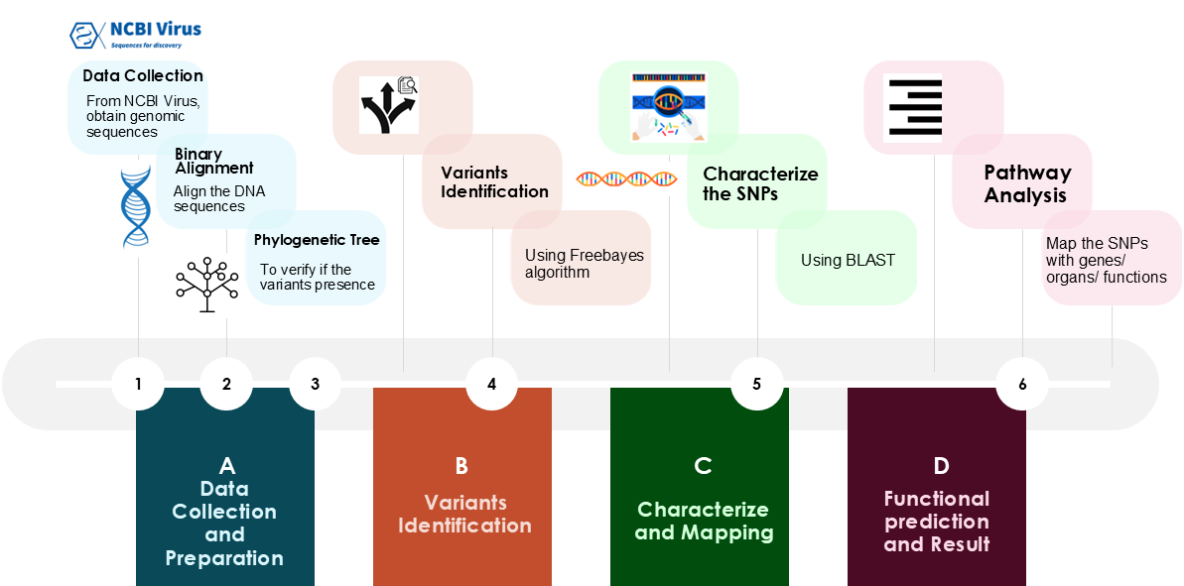

INNOVATION / CONTRIBUTION TO THE FIELD: The project focuses on the analysis of genomic sequences to identify and characterize genetic variants within a reference genome. Utilizing a suite of bioinformatics tools, the project integrates several key steps, including sequence alignment, variant calling, and impact assessment, to provide a comprehensive analysis of genomic data. This contributes to the field of Bioinformatics an effective tool that can be extended to analyze the genetic variation of other emerging organisms and derive insights

Internal Guide Signature of Assoc. Dean Signature of the HOD
Dr. Hemavathy R Dr. Nagaraja G S Dr. Ramakanthkumar P
Assoc. Professor Professor and Assoc. Dean Professor and Head of the
Dept. of CSE, RVCE Dept. of CSE, RVCE Dept. of CSE, RVCE

